

**Capstone Project Report**

**Report 3 – Software Requirement Specification**

– Hanoi, August 2019 –

**Table of Contents**

I. Record of Changes 3

II. Software Requirement Specification 4

1. Product Overview 4

2. User Requirements 4

2.1 Actors 4

2.2 Use Cases 5

3. Functional Requirements 7

3.1 System Functional Overview 7

3.2 Home page 15

3.3 Login/Signup 15

3.4 House Detail 16

3.5 Room Detail 17

3.6 Report House 18

3.7 Register [Landlord] 18

3.8 Dashboard [Landlord] 21

3.9 Upload House Information [Landlord] 22

3.10 House Detail [Landlord] 22

3.11 Update House [Landlord] 23

3.12 Delete House [Landlord] 24

3.13 Update Room [Landlord] 24

3.14 Add Room [Landlord] 25

3.15 Delete Room [Landlord] 26

4. Non-Functional Requirements 27

4.1 External Interfaces 27

4.2 Quality Attributes 27

5. Requirement Appendix 28

5.1 Business Rules 28

5.2 Common Requirements 28

5.3 Application Messages List 28

5.4 Other Requirements… 29

# I. Record of Changes

|  |  |  |  |
| --- | --- | --- | --- |
| Date | A* M, D | In charge | Change Description |
| 05/10/2022 | A | GiangNT | Screen Flows |
| 06/10/2022 | A | KienNT | Screen Description; Screen Authorization |
| 07/10/2022 | A | HuyenBN | Use Case Diagram |
| 07/10/2022 | A | KienNT | Use Case Description |
| 07/10/2022 | M | GiangNT | Use Case Description |
| 08/10/2022 | A | HuyenBN | Entity Relationship Diagram |
| 08/10/2022 | A | KienNT | Entity Descriptions |
| 08/10/2022 | M | GiangNT | Entity Descriptions |
| 09/10/2022 | A | HuyenBN | Functional Requirements: HomePage, Login/Signup, House Detail, Room Detail, Report House |
| 09/10/2022 | A | GiangNT | Product Overview; Context Diagram |
| 09/10/2022 | A | GiangNT | User Requirements - Actors |
| 09/10/2022 | A | GiangNT | Non-screen functions |
| 10/10/2022 | A | KientNT | Functional Requirements: [Landlord] Register, Dashboard, Upload House Info, House Detail, Update House, Add House, Delete House, Update Room, Add Room, Delete Room |
| 10/10/2022 | M | GiangNT | Functional Requirements: [Landlord] Register, Dashboard, Upload House Info, House Detail, Update House, Add House, Delete House, Update Room, Add Room, Delete Room |
| 10/10/2022 | A | GiangNT | External Interfaces |
| 10/10/2022 | A | HuyenBN | Quality Attributes |
| 10/10/2022 | A | GiangNT | Business Rules |

*A - Added M - Modified D - Deleted

# II. Software Requirement Specification

## 1. Product Overview

The FU House Finder System is a new software system that helps the students and the landlords find each other through the Internet. The context diagram below illustrates the external entities and system interfaces for release 1.0. The system is expected to evolve over several releases, ultimately having the ability to recommend suitable houses for students based on view history and also earn money for the host.

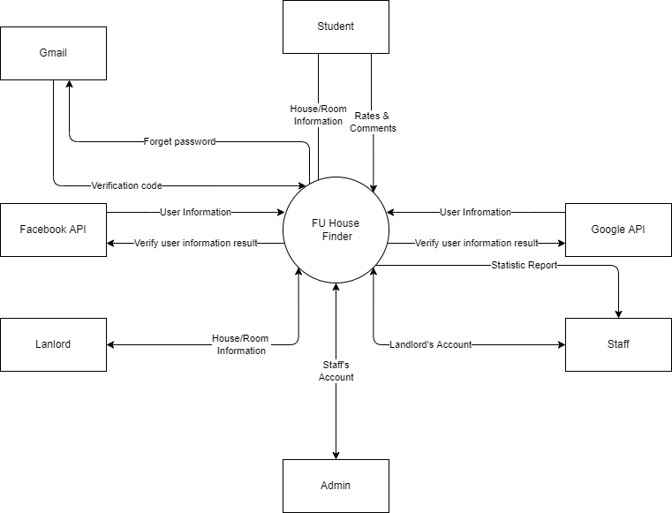

## 2. User Requirements

### 2.1 Actors

|  |  |  |
| --- | --- | --- |
| **#** | **Actor** | **Description** |
| 1 | Administrator | Administrator of the system; Manage accounts of Staffs |
| 2 | Staff | Staffs of the offices of the University; Manage accounts of Landlords and view statistics reports |
| 3 | Landlord | People having houses for rent; Manage their houses and rooms and their information |
| 4 | Student | People finding for houses to rent; Can search for available houses in the system |

### 2.2 Use Cases

#### 2.2.1 Diagram(s)

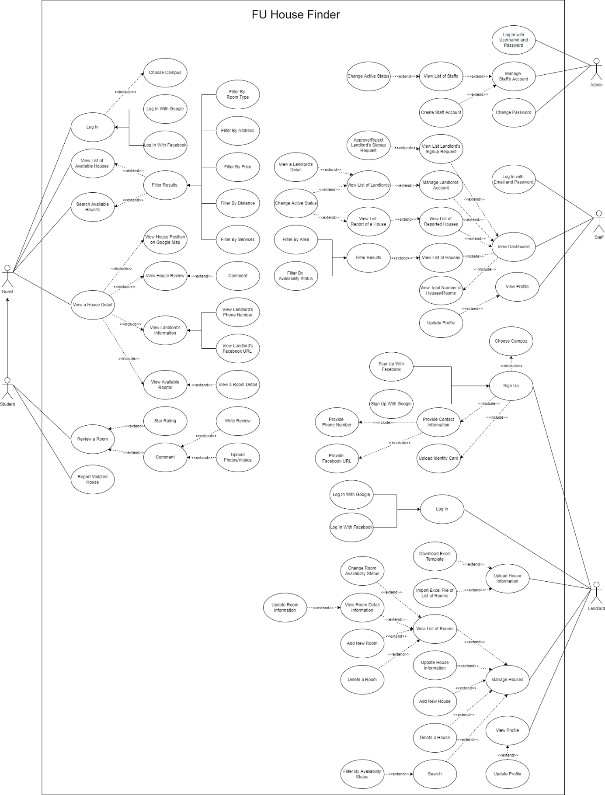

#### 2.2.2 Descriptions

|  |  |  |  |
| --- | --- | --- | --- |
| **ID** | **Use Case** | **Actors** | **Use Case Description** |
| 01 | Log In | Guest | Guest logs into the system |
| 02 | View List Of Available Houses | Guest | Guest views list of houses |
| 03 | Search Available Houses | Guest | Guest searches for houses by name or filters it by category or by map |
| 04 | View a House Detail | Guest | Guest views the detail information of house |
| 05 | Review a House | Student | Student rates and comments the house |
| 06 | Report Violated House | Student | Student reports the violated house |
| 07 | Log In with Email and Password | Admin | Admin logs into the system |
| 08 | Manage Staff’s Account | Admin | Admin views the list of all staff accounts and can be change active status of the staff |
| 09 | Change Password | Admin | Admin changes login password |
| 10 | Log In with Email and Password | Staff | Staff logs into the system |
| 11 | View Dashboard | Staff | Staff views list of available houses and list of landlord’s request. Staff can be search for houses & statistics by name or filter it by category at the same time can also accept or decline landlord’s request |
| 12 | View Profile | Staff | Staff views and updates the profile |
| 13 | Sign Up | Landlord | Landlord registers for an account |
| 14 | Log In | Landlord | Landlord logs into the system |
| 15 | Upload House Information | Landlord | Landlord imports information of the house by excel file |
| 16 | Manage Houses | Landlord | Landlord views list of rooms, detail information of room at the same time can also add new, update, delete, change status the room |
| 17 | View Profile | Landlord | Landlord views and updates the profile |

## 3. Functional Requirements

### 3.1 System Functional Overview

#### 3.1.1 Screens Flow

Student

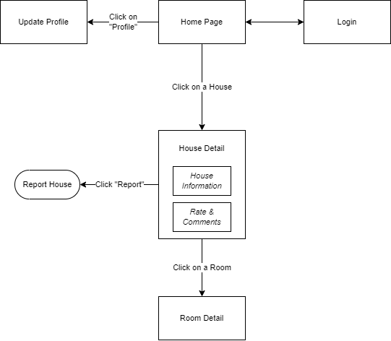

Figure 1-1: Screen Flow for Student

Landlord

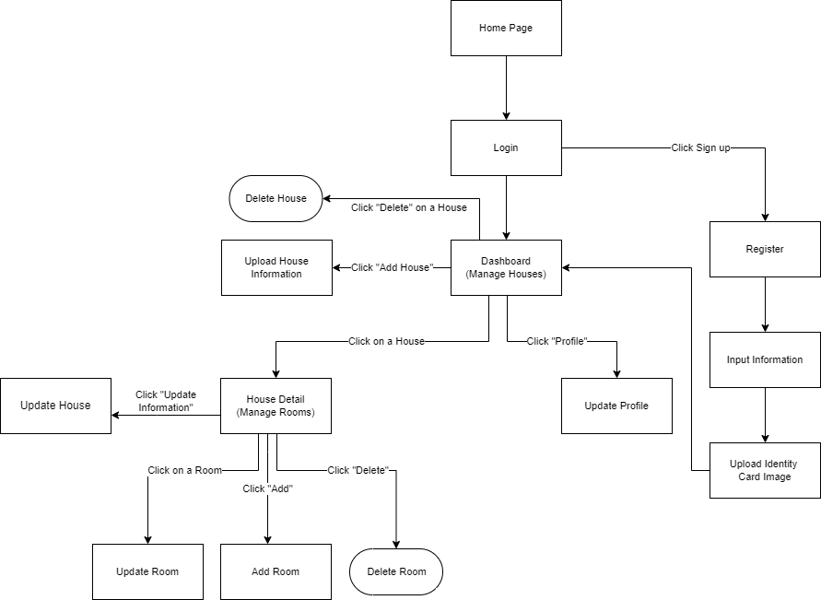

Figure 1-2: Screen Flow for Landlord

Staff

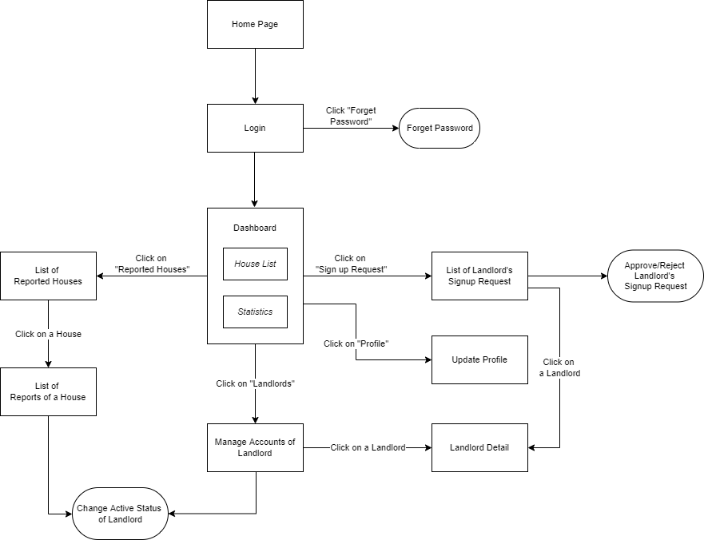

Figure 1-3: Screen Flow for Staff

Admin

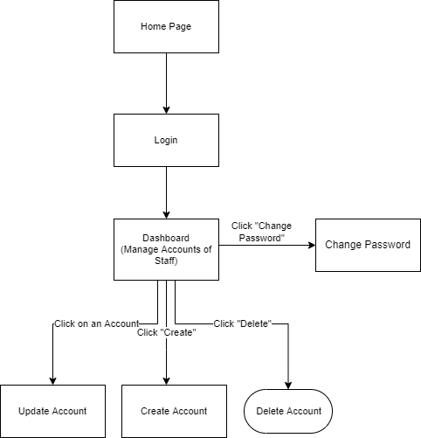

Figure 1-3: Screen Flow for Admin

#### 3.1.2 Screen Descriptions

|  |  |  |  |
| --- | --- | --- | --- |
| **#** | **Feature** | **Screen** | **Description** |
|  | View List Houses | Home Page | View list of houses |
|  | Search & Filter House | Home Page | Search for houses by name or filter it by category |
|  | Interact with map | Home Page | Use the map to find the location of the house |
|  | View House Detail | House Details | Display detail information of house |
|  | View Room Detail | Room Details | Display detail information of room |
|  | Report House | Report House | User reports the house |
|  | Login | User Login | User logs into the system |
|  | Register | User Register | User registers for an account |
|  | Register | Register [Landlord] | Landlord registers for an account |
|  | Verify Information Of Landlord | Input Information [Landlord] | Get information of landlord |
|  | Verify Identity Card Of Landlord | Upload Identity Card Image [Landlord] | Get identity card of landlord |
|  | View List Houses | Dashboard [Landlord] | Landlord views list of houses |
|  | Search & Filter House | Dashboard [Landlord] | Landlord searché for houses by name or filters it by category |
|  | Upload House Information | Upload House Information [Landlord] | Landlord imports information of the house |
|  | Manage Rooms | House Detail [Landlord] | Display detail information of house |
|  | Search & Filter Room | House Detail [Landlord] | Landlord searché for rooms by name or filters it by category |
|  | Update House | Update House [Landlord] | Landlord updates the house |
|  | Delete House | Delete House [Landlord] | Landlord deletes the house |
|  | Update Room | Update Room [Landlord] | Landlord updates the room |
|  | Add Room | Add Room [Landlord] | Landlord adds new the room |
|  | Delete Room | Delete Room [Landlord] | Landlord deletes the room |
|  | Update Proflie | Update Proflie [Landlord] | Landlord updates the proflie |
|  | View List Houses & Statistics | Dashboard [Staff] | Staff view list of available houses |
|  | Search & Filter House & Statistic | Dashboard [Staff] | Staff searches for houses & statistics by name or filter it by category |
|  | Accept Or Decline Landlord’s Signup Request | List Of Landlord’s Signup Request [Staff] | Staff views list of landlord’s request and accepts or decline |
|  | Update Proflie | Update Proflie [Staff] | Staff updates the proflie |
|  | View List Accounts Of Landlords | Landlords List [Staff] | Staff views list of landlords |
|  | View Landlord Detail | Landlord Detail [Staff] | Staff views detail information of landlord |
|  | View List Of Reported Houses | List Of Reported Houses [Staff] | Staff views list of reported houses |
|  | View List Accounts Of Staffs | Dashboard [Admin] | Admin views the list of all staff accounts |
|  | Search & Filter Staff | Dashboard [Admin] | Admin searches for staffs by name or filter it by category |
|  | Change Password | Change Password [Admin] | Admin changes login password |
|  | Create Staff Account | Create Account [Admin] | Admin creates account for staff |
|  | Update Staff Account | Update Account [Admin] | Admin updates account of staff |
|  | Detele Staff Account | Detele Account [Admin] | Admin deletes account of staff |

#### 3.1.3 Screen Authorization

|  |  |  |  |  |  |
| --- | --- | --- | --- | --- | --- |
| **Screen** | **Guest** | **Student** | **Landlord** | **Staff** | **Admin** |
| Home Page | X | X | X | X | X |
| House Details | X | X | X | X | X |
| Room Details | X | X | X | X | X |
| Report House |  | X |  |  |  |
| User Login |  | X | X | X | X |
| User Register | X |  |  |  |  |
| Register [Landlord] |  |  | X |  |  |
| Input Information [Landlord] |  |  | X |  |  |
| Upload Identity Card Image [Landlord] |  |  | X |  |  |
| Dashboard [Landlord] |  |  | X |  |  |
| Upload House Information [Landlord] |  |  | X |  |  |
| House Detail [Landlord] |  |  | X |  |  |
| Update House [Landlord] |  |  | X |  |  |
| Delete House [Landlord] |  |  | X |  |  |
| Update Room [Landlord] |  |  | X |  |  |
| Add Room [Landlord] |  |  | X |  |  |
| Delete Room [Landlord] |  |  | X |  |  |
| Update Proflie [Landlord] |  |  | X |  |  |
| Dashboard [Staff] |  |  |  | X |  |
| List Of Landlord’s Signup Request [Staff] |  |  |  | X |  |
| Update Proflie [Staff] |  |  |  | X |  |
| Landlords List [Staff] |  |  |  | X |  |
| Landlord Detail [Staff] |  |  |  | X |  |
| List Of Reported Houses [Staff] |  |  |  | X |  |
| Dashboard [Admin] |  |  |  |  | X |
| Change Password [Admin] |  |  |  |  | X |
| Create Account [Admin] |  |  |  |  | X |
| Update Account [Admin] |  |  |  |  | X |
| Detele Account [Admin] |  |  |  |  | X |

#### 3.1.4 Non-Screen Functions

|  |  |  |  |
| --- | --- | --- | --- |
| **#** | **Feature** | **System Function** | **Description** |
| 1 | Login with Facebook | Login | User logs in the system with his Facebook account |
| 2 | Login with Google | Login | User logs in the system with his Google account |
| 3 | Import File Excel | Sign up & Manage Houses | Convert data from Excel file into house & room information |
| 4 | Forget Password | Login | System send verification code to user Email to reset password |

#### 3.1.5 Entity Relationship Diagram

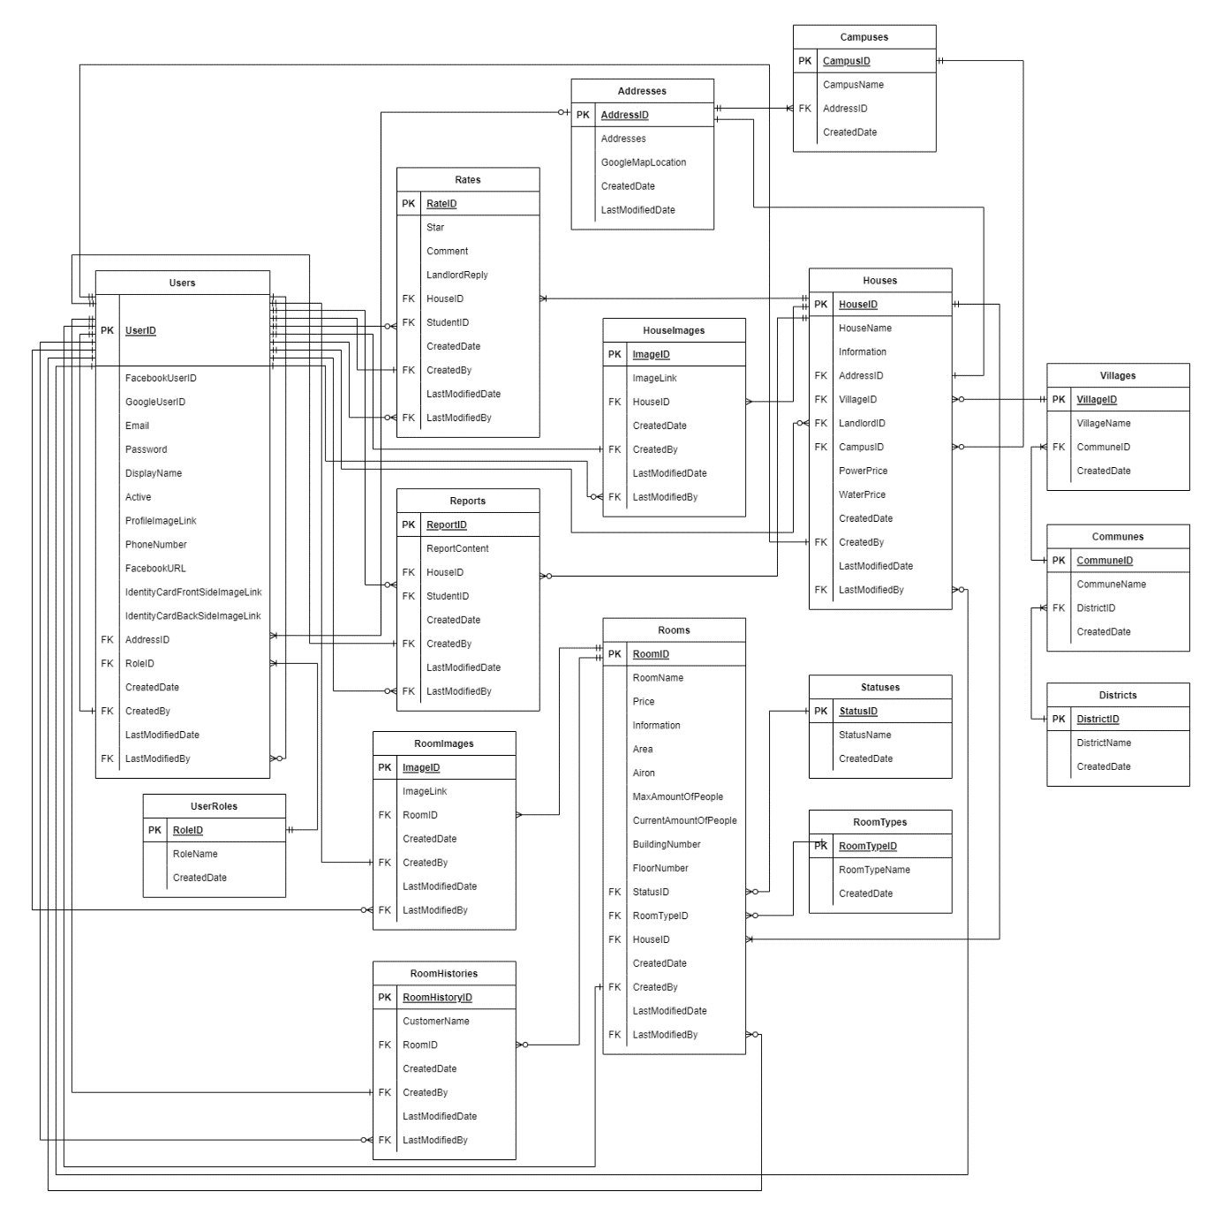

**Entities Description**

|  |  |  |
| --- | --- | --- |
| **#** | **Entity** | **Description** |
| 1 | Addresses | Used to store the address of User, House & Campus |
| 2 | Campuses | Used to store Campuses of FPT university |
| 3 | UserRoles | Used to store the role of each User |
| 4 | Users | Used to store Users in the system |
| 5 | Districts | Used to store Districts around the school |
| 6 | Communes | Used to store Communes around the school |
| 7 | Villages | Used to store Villages around the school |
| 8 | Houses | Used to store Houses |
| 9 | Statuses | Used to store Statuses of Room |
| 10 | RoomTypes | Used to store Types of Room |
| 11 | Rooms | Used to store Rooms |
| 12 | Rates | Used to store Rating & Comments of User |
| 13 | ImagesOfHouse | Used to store Images of House |
| 14 | ImagesOfRoom | Used to store Images of Room |
| 15 | Reports | Used to store student's Reports for House |
| 16 | RoomHistories | Used to store Histories of people staying in the House, for the landlord to voluntarily add if there is a need to manage & monitor |

### 3.2 Home page

* Function trigger: User accesses the website
* Function description:
  + Role: Guest, Student
  + Purpose: User could view list of available houses and filter the results
* Screen layout:

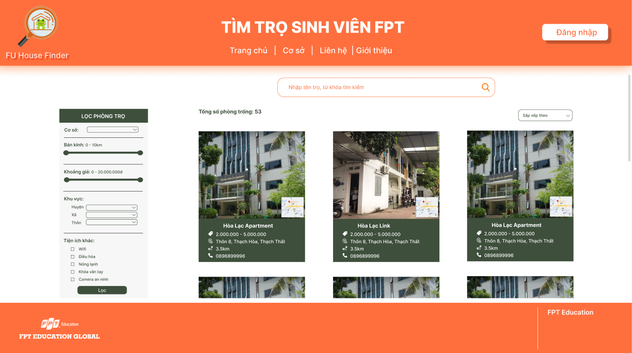

### 3.3 Login/Signup

* Function trigger: User clicks “Đăng nhập” from Home Page
* Function description:
  + Role: Guest
  + Purpose: Guest could sign up for an account or log in to access more functions
* Screen layout: 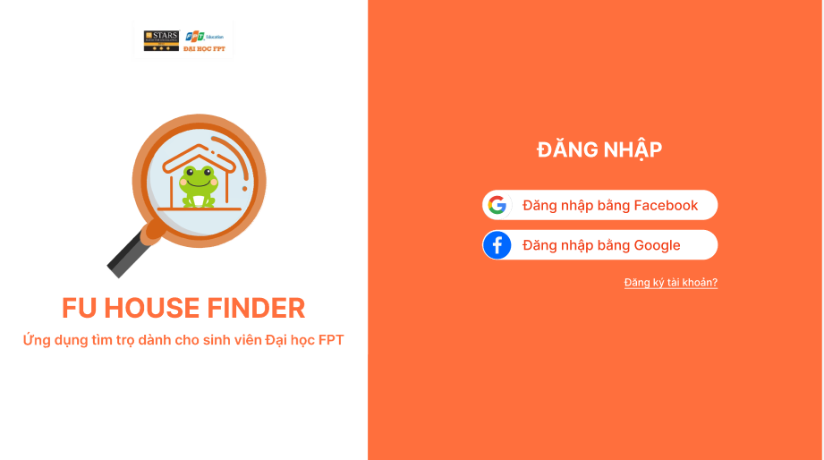

### 3.4 House Detail

* Function trigger: User clicks on one house from Home page
* Function description:
  + Role: Guest, student
  + Purpose: View a house detail information (landlord’s information, available rooms, etc.)
* Screen layout: 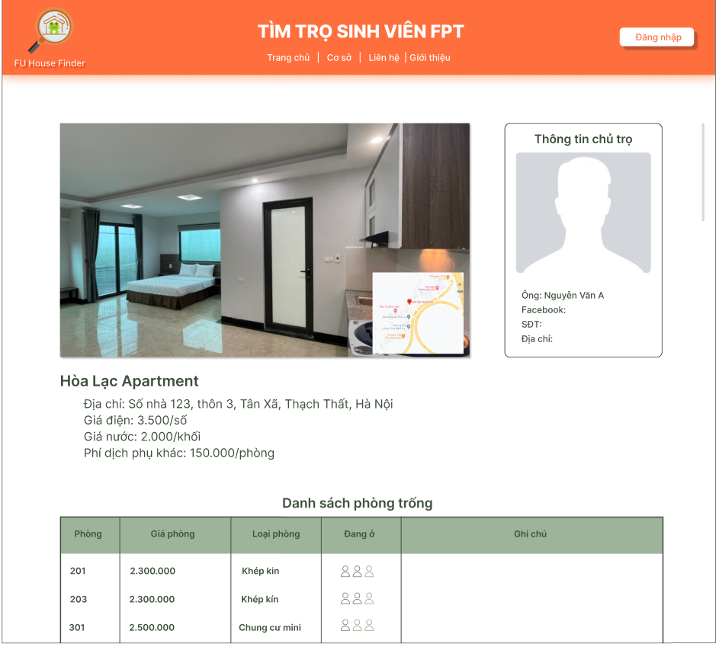

### 3.5 Room Detail

* Function trigger: User clicks on one Room from a House Detail
* Function description:
  + Role: Guest, student
  + Purpose: View a room detail information (images, price, etc.)
* Screen layout: 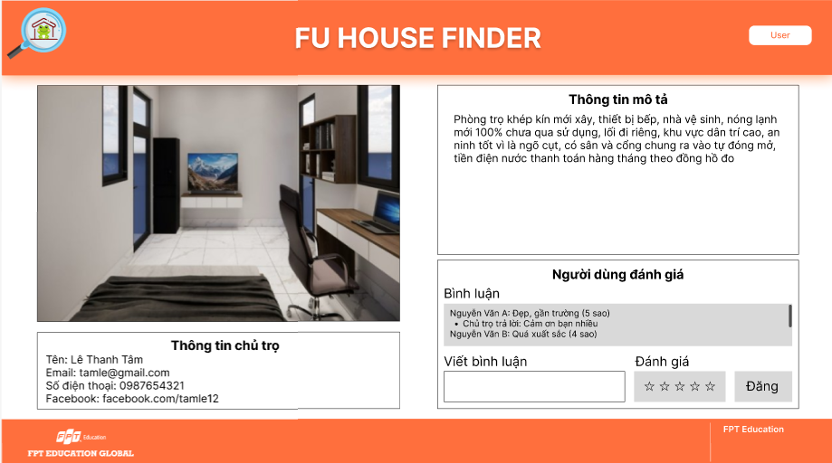

### 3.6 Report House

* Function trigger: Student clicks “Báo cáo” in one House Detail
* Function description:
  + Role: Student
  + Purpose: Student uses to report an unusual house
* Screen layout:

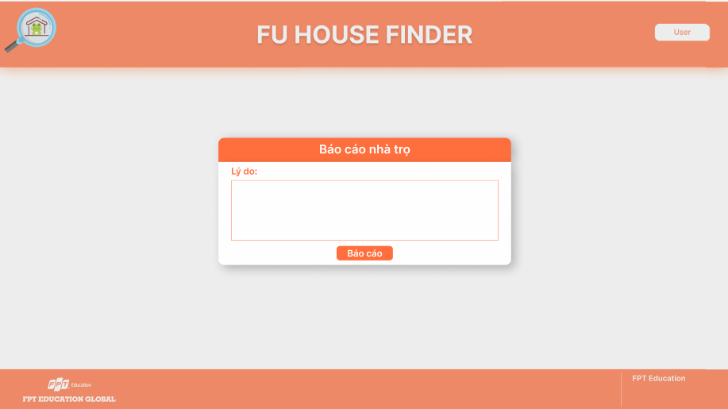

### 3.7 Register [Landlord]

* Function trigger: User click the landlord’s register button
* Function description:
  + Role: Guest
  + Purpose: Landlord register for an account
* Screen layout:

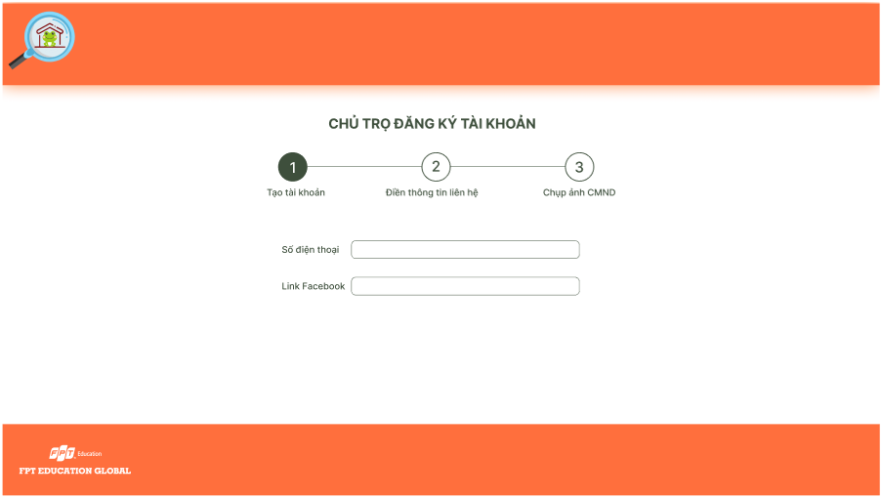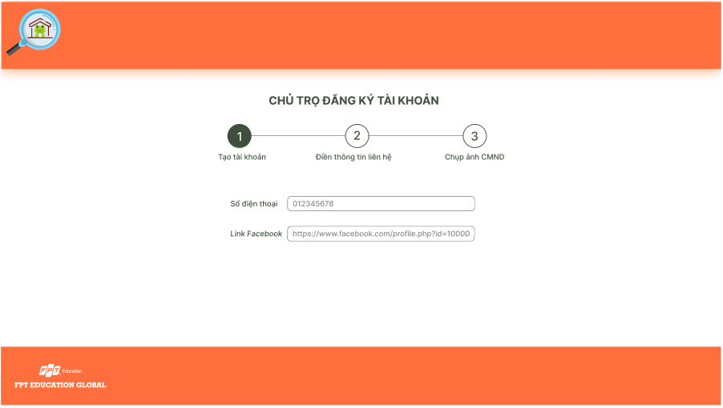 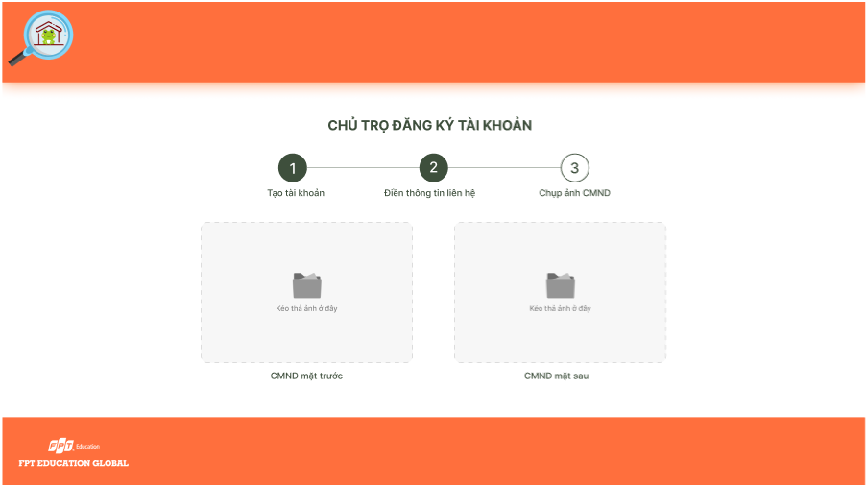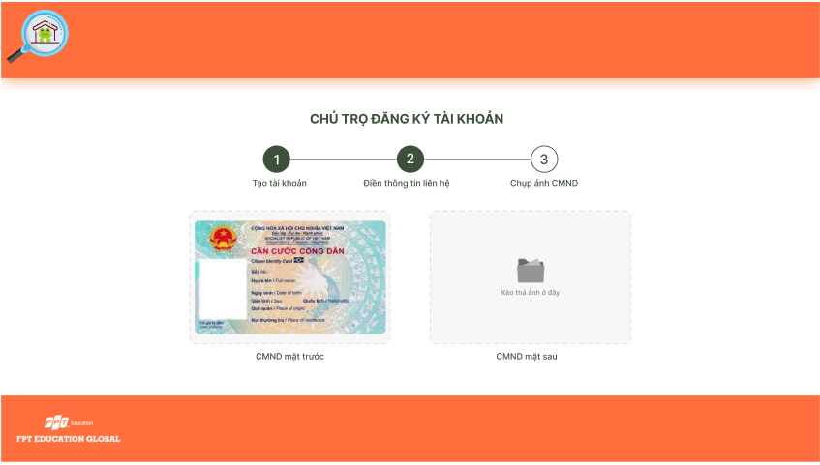 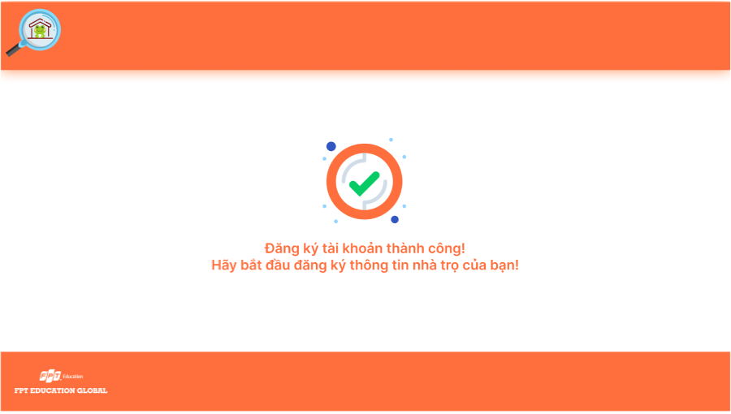

### 3.8 Dashboard [Landlord]

* Function trigger: Landlord accesses the website
* Function description:
  + Role: Landlord
  + Purpose: Landlord view list of houses and search for houses by name or filter it by category
* Screen layout:

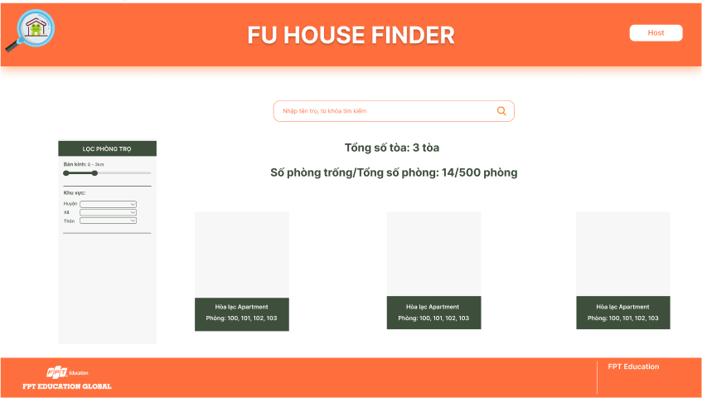

### 3.9 Upload House Information [Landlord]

* Function trigger: Landlord clicks the import button
* Function description:
  + Role: Landlord
  + Purpose: Landlord import information of the house
* Screen layout:

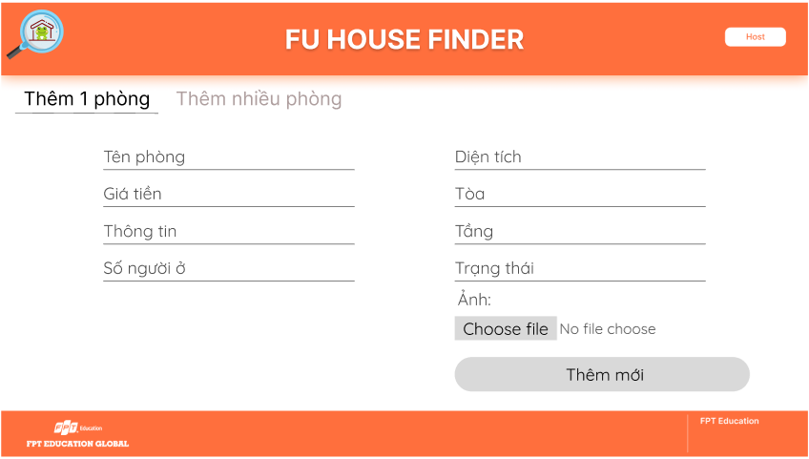 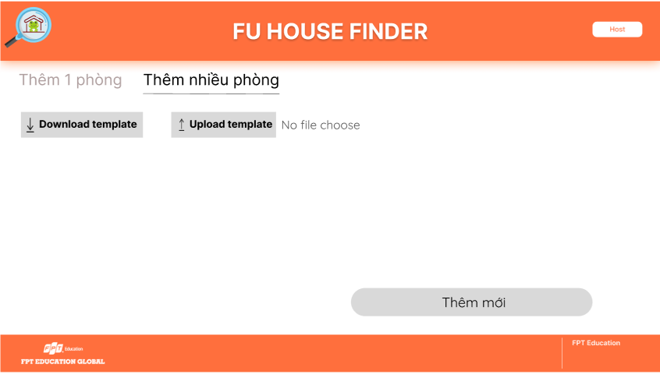

### 3.10 House Detail [Landlord]

* Function trigger: Landlord clicks each item of list houses
* Function description:
  + Role: Landlord
  + Purpose: Display detail information of house and search for rooms by name or filter it by category
* Screen layout:

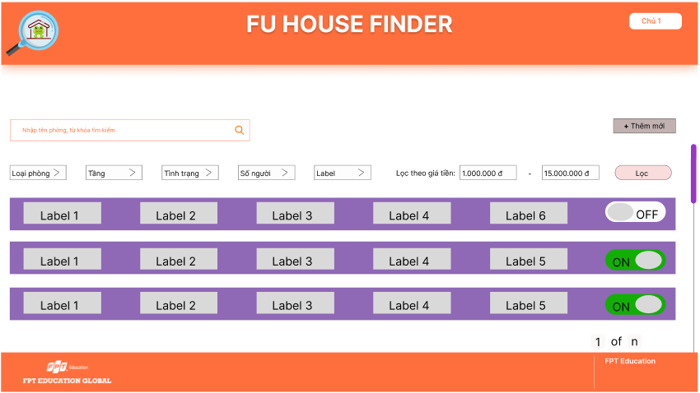

### 3.11 Update House [Landlord]

* Function trigger: Landlord clicks the update button
* Function description:
  + Role: Landlord
  + Purpose: Landlord update the house
* Screen layout:

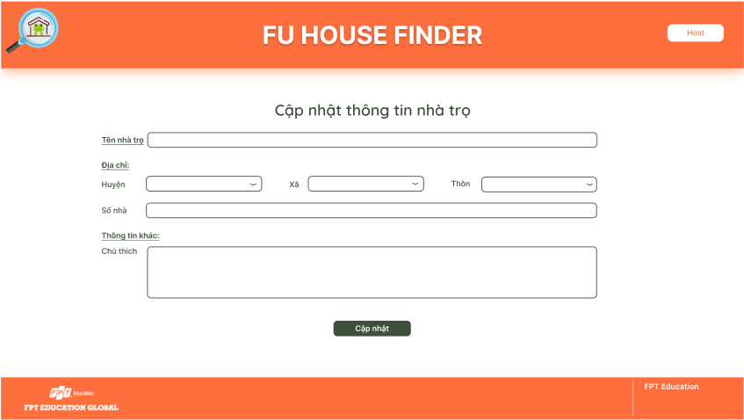

### 3.12 Delete House [Landlord]

* Function trigger: Landlord clicks the delete button
* Function description:
  + Role: Landlord
  + Purpose: Landlord delete the house
* Screen layout:

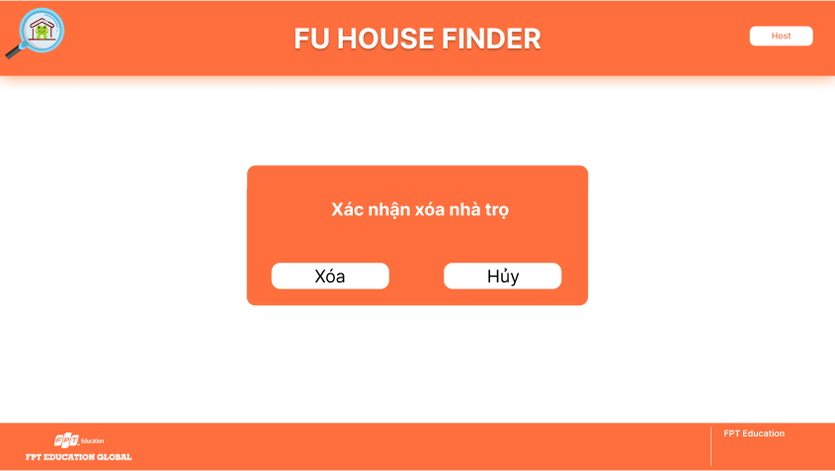

### 3.13 Update Room [Landlord]

* Function trigger: Landlord clicks the update button of each room in the list
* Function description:
  + Role: Landlord
  + Purpose: Landlord update the room
* Screen layout:

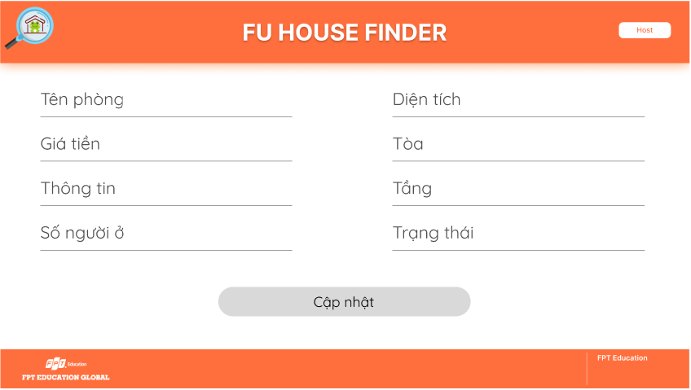

### 3.14 Add Room [Landlord]

* Function trigger: Landlord clicks the add button
  + Function description:
  + Role: Landlord
* Purpose: Landlord add the new room
* Screen layout:

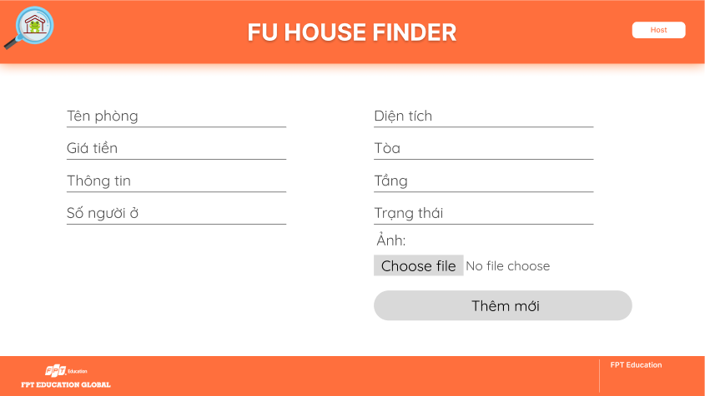

### 3.15 Delete Room [Landlord]

* Function trigger: Landlord clicks the delete button of each room in the list
* Function description:
  + Role: Landlord
  + Purpose: Landlord delete the room
* Screen layout:

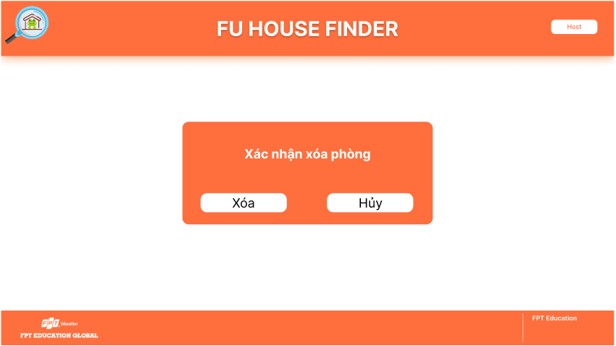

## 4. Non-Functional Requirements

### 4.1 External Interfaces

#### 4.1.1 User Interfaces

UI-1: The FU House Finder System screen displays shall conform to the User Interface Design and User Experience Design

UI-2: The website is designed with the feature of using Angular framework to provide a smooth user experience without having to reload the website many times.

#### 4.1.2 Software Interfaces

SI-1: FU House Finder Account Checking system

SI-1.1: Upload existing user data in the system through a programming interface

SI-1.2: The system automatically checks what state the account is in in the Active attribute of User table

SI-1.3: There will be 2 states including Active and Deactive. If the account is Active, you will be able to perform actions to the system (including managing Landlord’s accounts if you are Staff, and managing Houses if you are Landlord). If the account is Deactive, you will not be able to log in to perform any actions.

SI-2: FU House Finder Inventory System

SI-2.1: House Finder System shall transmit the quantities of house and room items to the House Finder Inventory System through a programmatic interface.

SI-2.2: House Finder System shall poll the House Finder Inventory System to determine whether a requested house item is available.

SI-2.3: The House Finder System will display the available houses left in system for the searching students. If the house is not available, the system will not display for the student to see.

#### 4.1.3 Hardware Interfaces

No hardware interfaces have been identified.

#### 4.1.4 Communication Interfaces

CI-1: FU House Finder shall send an email or send a message to a phone number (based on user account settings) to the Landlord to report any problems reported by students, the Landlord then will present at University campus to resolve.

### 4.2 Quality Attributes

#### 4.2.1 Availability

AVL-1: The FU House Finder website shall be available at least 98% of the time between 5:00 A.M. and midnight local time and at least 90% of the time between midnight and 5:00 A.M. local time, excluding scheduled maintenance windows.

#### 4.2.2 Usability

USB-1: The website shall be designed with user-friendly interfaces so that users could complete the main actions once they see the interface.

USB-2: Landlords shall import the list of their houses within 5 steps.

#### 4.2.3 Localization

LCL-1: The date format must be as follows: date/month/year.

#### 4.2.4 Performance

PE-1: The website must provide 7 seconds or less respond time in a Chrome browser in peak usage condition.

PE-2: The web pages shall fully load in an average of 5 seconds in normal condition.

#### 4.2.5 Security

SE-1: Only admin shall be able to create a new staff’s account and only staff shall be able to approve/reject landlords’ signup request.

SE-2: Landlords must provide their identity card image to be able to sign up a landlord account.

## 5. Requirement Appendix

### 5.1 Business Rules

|  |  |
| --- | --- |
| ID | Rule Definition |
| BR-01 | Only Staff can approve Landlord’s Sign up request and Deactive Landlord’s account. |
| BR-02 | Only Admin can create, modify, or deactive Staff’s account. |
| BR-03 | Landlord can only upload House information after sign up request being approved by Staff. |
| BR-04 | All Passwords require 256-bit encryption. |
| BR-05 | Student’s Search functionality requires at least searching by distance from campus, price and utility. |
| BR-06 | Landlord’s House information upload must adhere to the rules of the template |

### 5.2 Common Requirements

### 5.3 Application Messages List

|  |  |  |  |  |
| --- | --- | --- | --- | --- |
| **#** | **Message code** | **Message Type** | **Context** | **Content** |
| 1 | MSG01 | In line | There is not any search result | *No search results.* |
| 2 | MSG02 | In red, under the text box | Input-required fields are empty | *The * field is required.* |
| 3 | MSG03 | Toast message | Updating asset(s) information successfully | *Update asset(s) successfully.* |
| 4 | MSG04 | Toast message | Adding new asset successfully | *Add asset successfully.* |
| 5 | MSG05 | Toast message | Confirming email of asset hand-over is sent successfully | *A confirmation email has been sent to {email_address}.* |
| 6 | MSG06 | Toast message | Resetting asset information successfully | *Return asset(s) successfully.* |
| 7 | MSG07 | Toast message | Deleting asset information successfully | *Delete asset(s) successfully.* |
| 8 | MSG08 | In red, under the text box | Input value length > max length | *Exceed max length of {max_length}.* |
| 9 | MSG09 | In line | Username or password is not correct when clicking sign-in | *Incorrrect user name or password. Please check again.* |

### 5.4 Other Requirements…